**UNIVERSITY OF INFORMATION TECHNOLOGY, VNU-HCM**

**COMPUTER NETWORKS AND DATA COMMUNICATION**

MOBILE DEVELOPMENT



FINAL PROJECT DOCUMENT REPORT

**Title of project**: Indoor Air Quality Monitoring Application

**Group: 8**

**Members of the group:**

| **Number** | **Name** | **Student ID** |
| --- | --- | --- |
| 1 | Võ Tín Thiện | 21521467 |
| 2 | Nguyễn Khánh Duy | 20521240 |
| 3 | Trần Công Hải | 21520811 |

**Instructor:** Phd Lê Kim Hùng, MS Thái Huy Tân

**Execution time:** 5/8/2023 – 12/12/2023

*Hochiminh city, December 12th 2023*

*I.* Introduction and project overview 4

*II.* System desgin overview 5

1. Usercase diagram 5

2. Userflow digram 6

2.1 Home page 6

2.2 Sign Up 6

2.3 Login 7

2.4 Map Interface 7

2.5 Dasboard Interface 8

2.6 Chart Interface 8

2.7 User Interface 9

3. Initial Desgin 9

*III.* Application Desgin and Features 10

1. Interface and features 10

1.1 Splash Screen 10

1.2 Home Screen 11

1.3 SignUp Screen 14

1.4 Login Screen 15

1.5 Map Screen 16

1.6 Graph Screen 18

1.7 Dashboard Screen 20

1.8 User Screen 22

22

2. Pros and cons 22

*IV.* Coclusion 23

1. Acomplished goal and conclusion 23

2. Future Improvement 23

# Introduction and project overview

- In the rapidly advancing landscape of technology, addressing crucial environmental concerns has become imperative. The Android Course Final Project presents a groundbreaking endeavor: the creation of an innovative Indoor Air Quality Monitoring Application. This project stands as a testament to the convergence of technology and health, aiming to empower users with a comprehensive toolset to track, analyze, and improve indoor air quality.

- The application will be responsible for collecting data from multiple cloud devices that measure various air quality parameters like temperature, humidity, and levels of pollutants like CO2 and particulate matter (PM2.5). This data will be visually presented to the user through an intuitive interface and should offer both current readings and historical trends. Moreover, the application should provide real-time alerts based on custom or predefined thresholds of these parameters.

- User can view the graph of the collected data, check the weather within 1 month, also user can use mapview to see the current location of the devices and see its data.

- The application also provides a user-friendly interface to track comprehensive weather-related data and more.

# System design overview

## Usercase diagram

Ảnh có chứa ảnh chụp màn hình, văn bản

Mô tả được tự động tạo

Overview

Ảnh có chứa ảnh chụp màn hình, vòng tròn, biểu đồ, thiết kế

Mô tả được tự động tạo

Detail

Ảnh có chứa ảnh chụp màn hình, vòng tròn, biểu đồ

Mô tả được tự động tạo

Detail

## User Flow diagram

### Home page

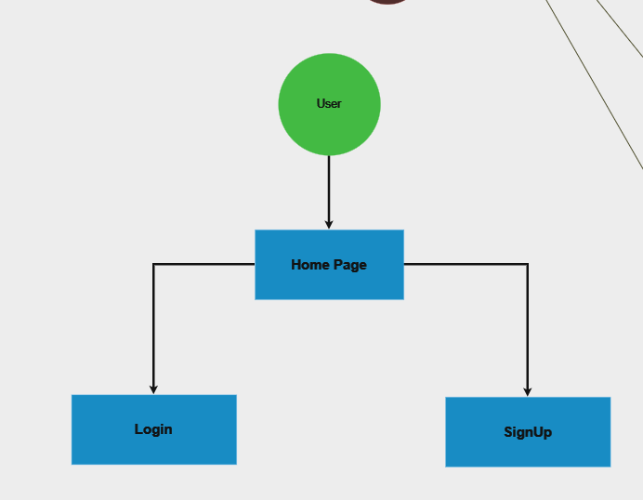

### Sign Up

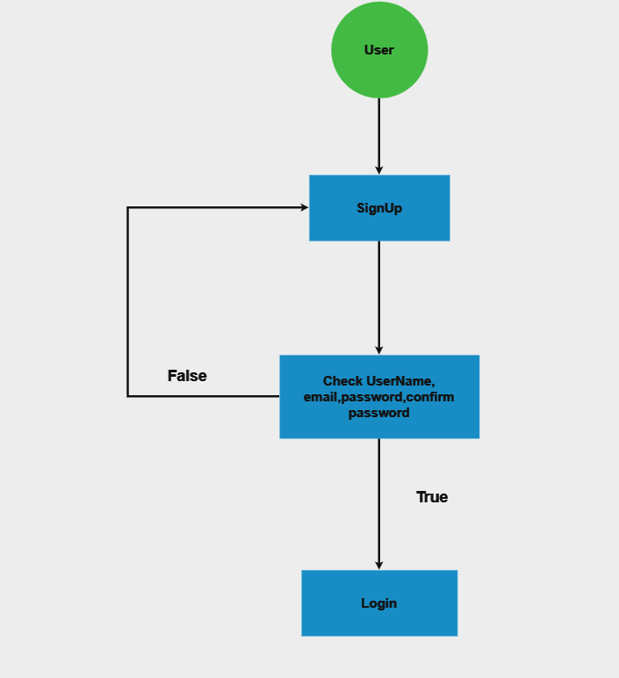

### Login

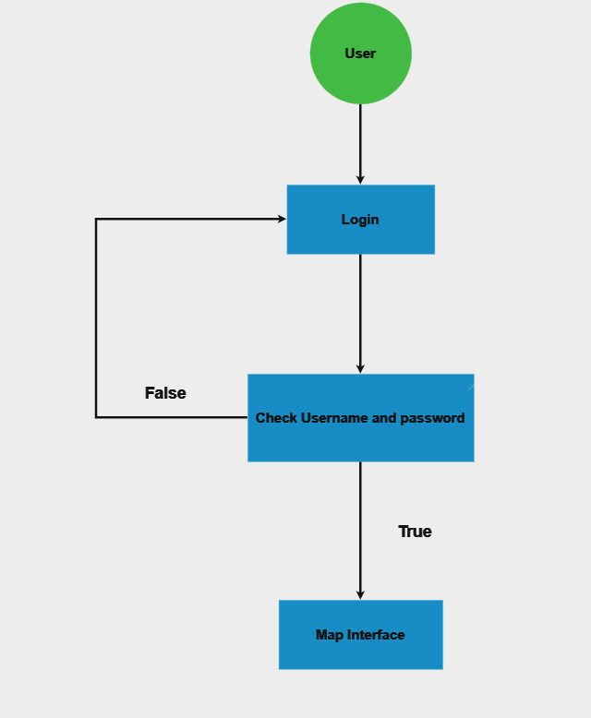

### Map Interface

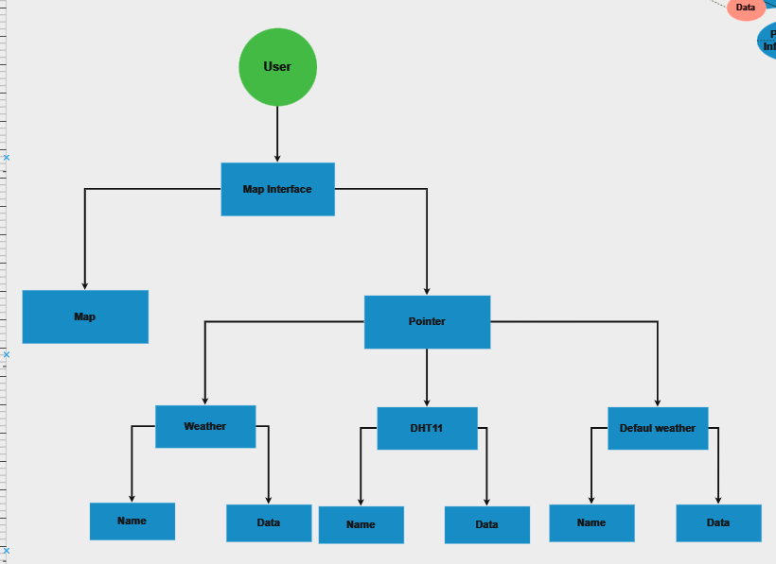

### Dashboard Interface

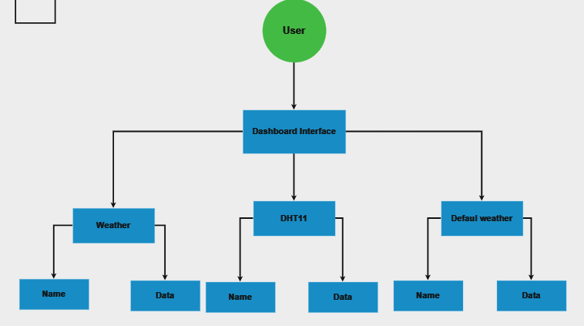

### Chart Interface

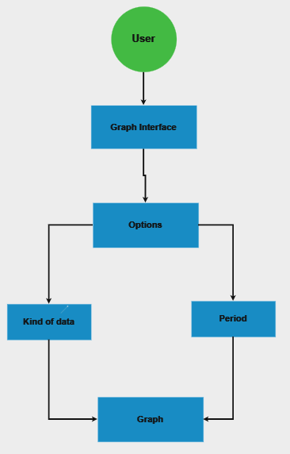

### User Interface

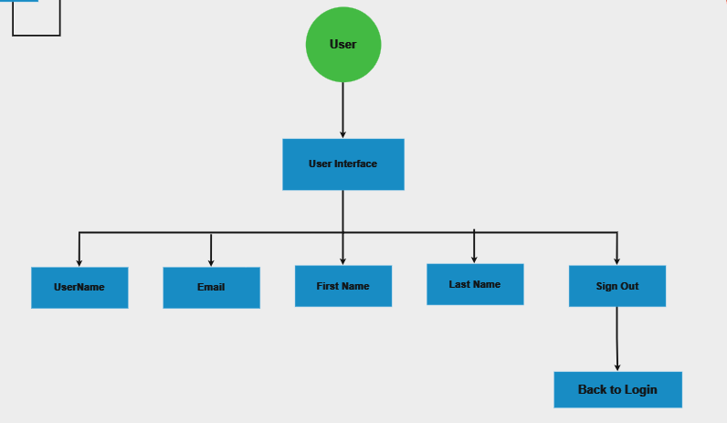

## Initial Design

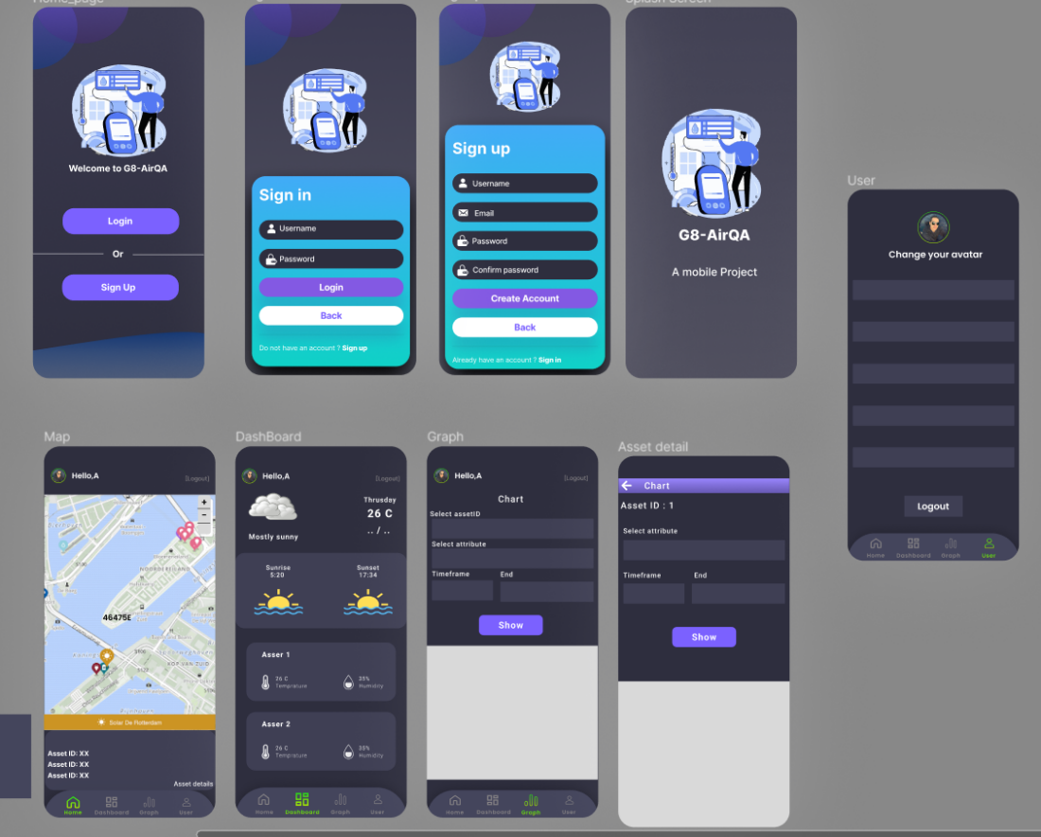

# Application Design and Features

## Interface and features

### Splash Screen

+ Splash screen before starting the application

### Home Screen

Pic 1: Home Screen

+ This is the Home Screen after the Splash Screen and here we have 3 options to choose:

* Sign Up button will lead you to the signup screen
* Login button will lead you to the Login screen
* Language icon where you can choose between 3 options to change the current languages : French, Vietnamese and English.
* A screenshot of a phone

  Description automatically generated

Language you can choose from

Pic 2: After you change your current language to French

### SignUp Screen

Pic 3: Sign Up Screen

+ This is the Sign Up Screen after when you click SignUp button at Home Screen and here we have 3 options to choose:

* Sign Up button : After you touch this button, the system will check your username, email, password, current password to see whether the email or username already exists and whether the password and current password is the same. If not then the system will tell you that sign up is complete and you will be brought to the Login Screen.
* Back button : It will return to the Home Screen if you click it
* Already have an account? Login Now : It will bring to the Login Screen if you already have an account.

### Login Screen

Pic 4: Login Screen

+ This also have 3 options:

* Login Button : The system will check if the username and password is correct to bring you to the Map Screen
* Back button: Bring you back to Home Screen
* Not yet registered? SignUp Now : It will bring you to SignUp Screen if you don’t have an account

### Map Screen

Pic 5: Map Screen

+ This is the Map Home Screen what you can see is the Map and the current location of all the asset in UIT area

+ There are things you can do in this screen

* You can choose to move to another Screen by touching the icon in the Bottom navigation bar below
* You can choose a location that you see the hand is pointing and they will show you the asset Name and data of the asset you choose like the screen below

Pic 6 : After you choose a ponting location in the map

### Graph Screen

Pic 7: Graph Screen

+ In this Graph Screen you will see a hello text and a logout icon on the top. The logout icon will bring you back to the Login Screen if you touch it

+ In The middle of the Graph is the edit text where you can write down the asset name attribute, and the period to show in another screen the graph of the attribute you choose and the period you want to see after you touch the show graph button

Pic 8 : Graph Screen

+ This is what you can see after you do these things above

### Dashboard Screen

Pic 9 : Dashboard Screen

+ This is the Dashboard Screen where you can see all of the current asset and their highlight data if you touch the “More>>>” text all of the asset data will be shown to you

Pic 10: After you touch the "More>>>” text

### User Screen

Pic 11: User Screen

+ This is the last Screen where it show your profile Account and a Sign Out button to Sign Out and get back to the Login Screen

## Pros and cons

| Pros | Cons |
| --- | --- |
| * Easy to use to understand and use * User-friendly interface | * Don’t have a lot of features for user to interact with * User experience still not optimized yet |

# Conclusion

## Accomplished goal and conclusion

* Our Project has met all the fundamental requirements that this Project needed and our team has gained a lot of knowledge, experience when working with the project as a team and learning more about developing an Android app and system.
* We have the capability to develop a dependable indoor air quality application, offering a user-friendly interface to track comprehensive weather-related data and more.​ The application can also track the asset current location, provides user information, show graph,…
* We also apply our knowledge about analyzing and designing the system to solve some problems when coding. We have successfully to implemented this application but due to time and limited programming skills the app wasn’t fully perfected and still need more improvements in the future

## Future Improvement

* We aim to enhance the user experience by incorporating additional features and refining the user interface, ensuring a more user-friendly and convenient experience with the app.​

​

* We also want to try to integrate AI technology into this project to enable predictive capabilities for parameters such as temperature, humidity, and other related factors.

References:

* Instructor’s lecture slides: Mobile development
* [**https://developer.android.com/docs**](https://developer.android.com/docs)